I started up with collecting all the image of vehicles and non-vehicles in the dataset.  
I have added 30 samples of non-vehicles data from the project video. Below are some of the samples:

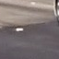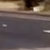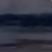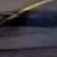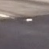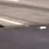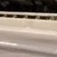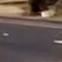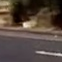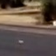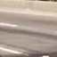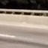

After adding them I had total of 9007 examples of non-vehicles and 8792 examples of vehicles. After this I had to extract features from these images using different color-maps and different techniques like patial bin, HOG features.

I tried different combinations of these techniques and finally settled on the HOG features for YUV colorspace and HLS colorspace. Below is the visualization of all the channels in HOG Image:

Original Image

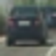

HLS Image H-Channel HOG L-Channel HOG S-Channel HOG

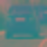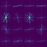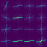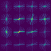

Y-Channel HOG U-Channel HOG V-Channel HOG

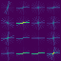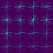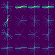

Also apart from this I have taken the RGB Histogram features with 32 bins.

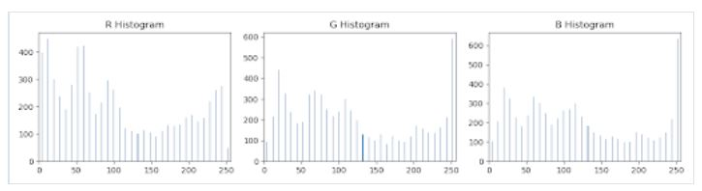

After adding all these features I got the feature vector of size 2472 features. Using these features I trained my SVC model with linear kernel as well as rbf kernel. Below is the summary of different combinations I evaluated:

|  |  |  |  |  |  |  |
| --- | --- | --- | --- | --- | --- | --- |
| S No. | Kernel | Features | f_size | Test_Accuracy | Extraction time(sec) | Training time(sec) |
| 1 | Linear | LS(Spatial),RGB,HOG 9,8,8,2 | 3908 | 0.9711 | 170.23 | 113 |
| 2 | rbf | LS(Spatial),RGB,HOG 9,8,8,2 | 3908 | 0.9858 | 170.23 | 189 |
| 3 | Linear | HOG Features for YUV and HLS with RGB hist | 2472 | 0.9858 | 123 | 9 |
| 4 | rbf | HOG Features for YUV and HLS with RGB hist | 2472 | 0.9919 | 123 | 49.4 |
| 5 | Linear | HOG Features for YUV,RGB and HLS with RGB hist | 3660 | 0.9867 | 168.66 | 15.2 |
| 6 | rbf | HOG Features for YUV,RGB and HLS with RGB hist | 3660 | 0.9923 | 168.66 | 124.21 |

I have used 4th configuration for my project as it has optimum number of features and the training time is also good enough.

# Choosing Windows

**Start_x=550 End_x=1280 Start_y=400 End_y=640**

Window size=(64,64) with overlap of 40% in X-direction and 50% in Y-direction

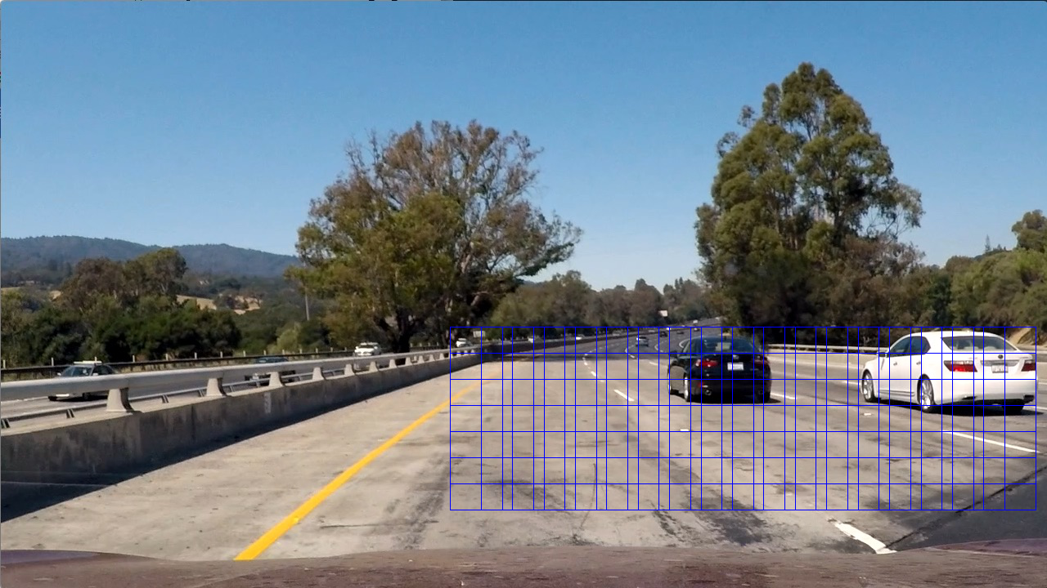

Window size=(125,110) with overlap of 70% in X-direction and 50% in Y-direction

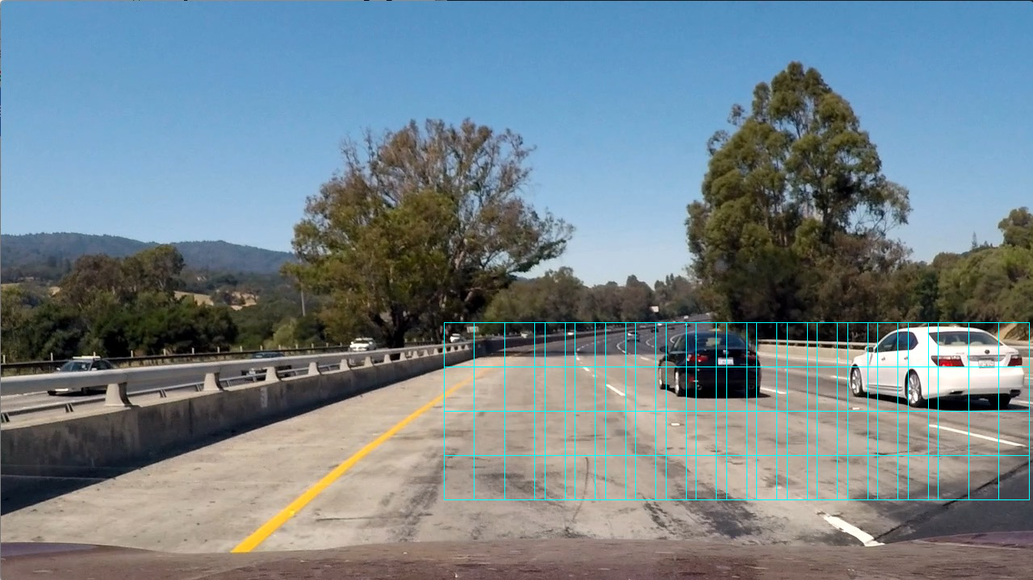

Window size=(100,80) with overlap of 70% in X-direction and 50% in Y-direction

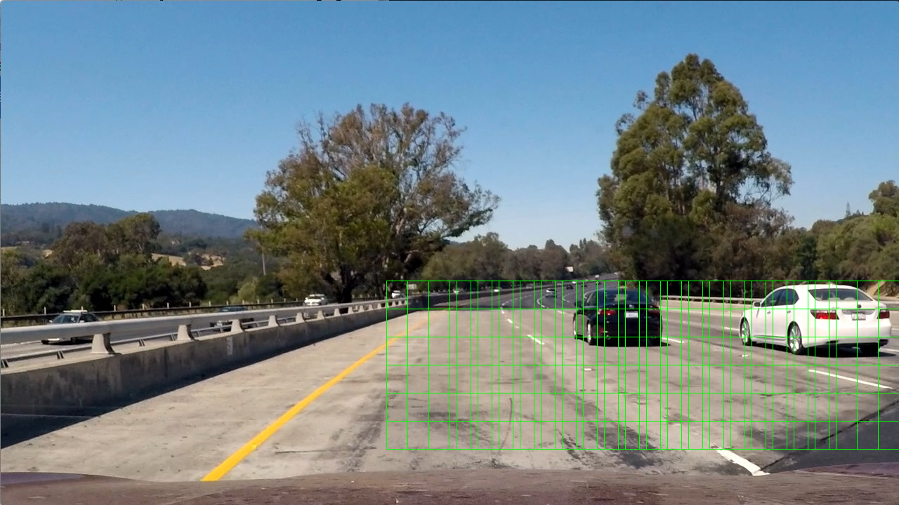

Window size=(130,130) with overlap of 70% in X-direction and 50% in Y-direction

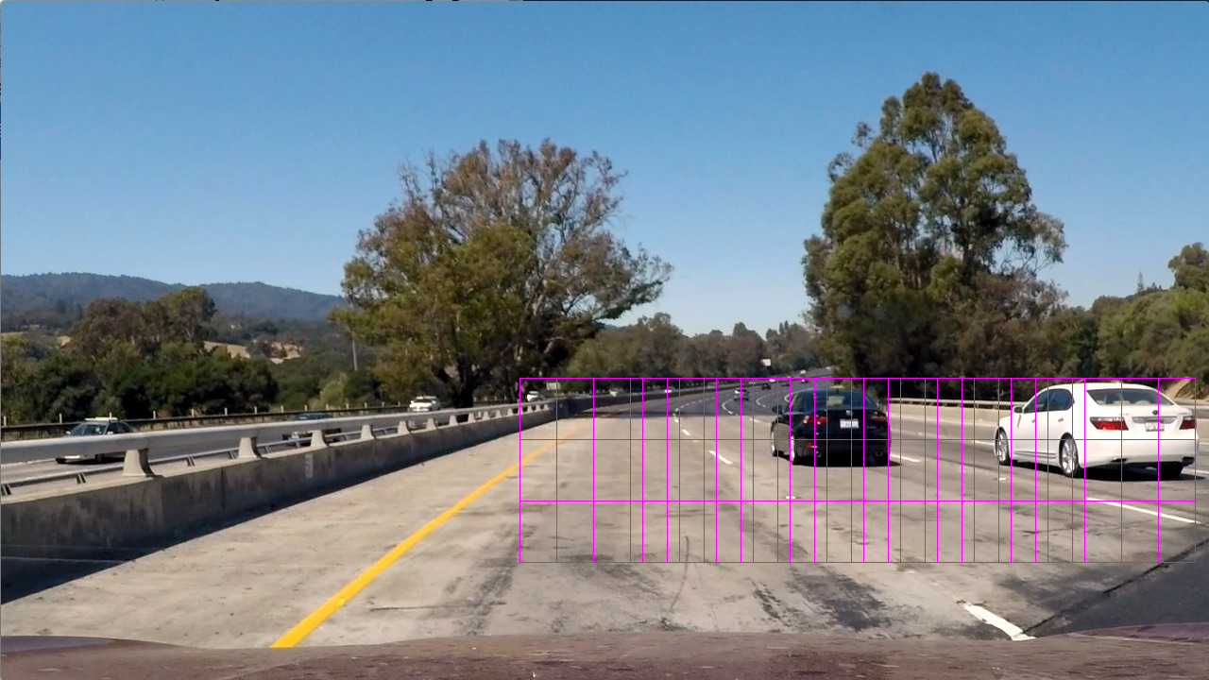

Window size=(80,75) with overlap of 70% in X-direction and 50% in Y-direction

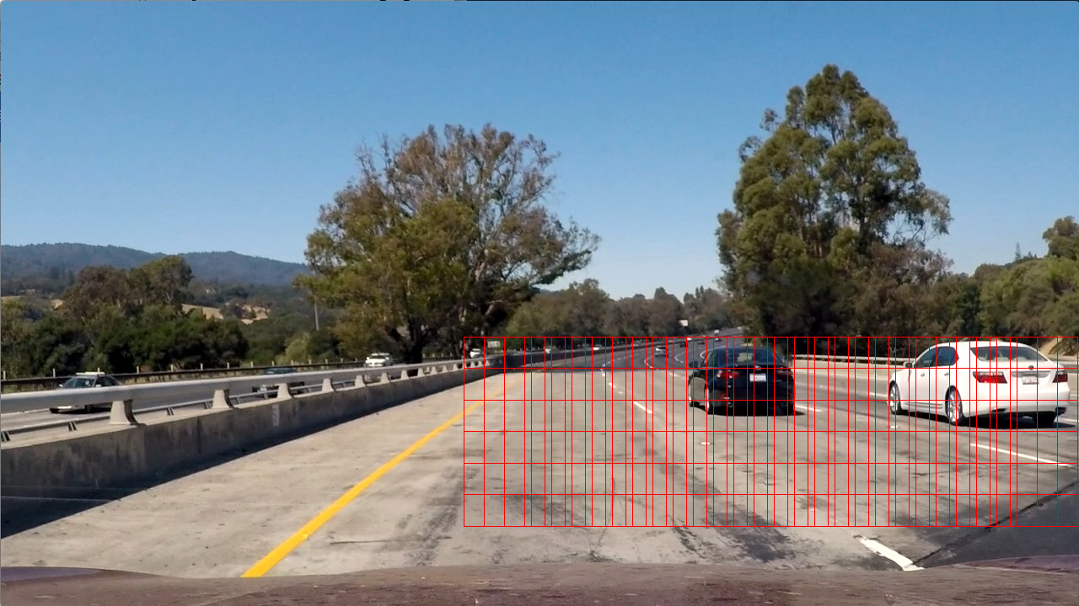

All the windows plotted on the same image:

